
Symbiosis Institute of Technology, Pune
CSE- Academic Year 2026-27
Java Programming – Lab Batch 2025-29
Lab Assignment No.:
Name of Student | Akshit Gawade
PRN No. | 25070122029
Batch | 2025-2029
Class | A1
Academic Year & Semester | Second Year  Semester III
Date of Submission
Title of Assignment: | Write a Java program to perform reading from and writing to a file using file handling operations.
Problem Statement  &  Learning  Objective | Problem Statement  Write a Java program to perform reading from and writing to a file using file handling operations.  Learning Objectives  To perform file reading and writing operations using Java file handling classes.
Theory | Java provides file handling through the java.io package. Classes such as File, FileReader, FileWriter, BufferedReader, and BufferedWriter are used to perform input and output operations. File handling enables permanent storage and retrieval of application data. Proper exception handling is necessary to manage file-related errors. These concepts are essential for data persistence.
Program Code | import java.io.*;  public class Main {  public static void main(String[] args) {  try {  FileWriter fw = new FileWriter("Exp13/data.txt");  fw.write("Hello, this is a Java file handling program.");  fw.close();  FileReader fr = new FileReader("Exp13/data.txt");  BufferedReader br = new BufferedReader(fr);  String line;  while ((line = br.readLine()) != null) {  System.out.println(line);  }  br.close();  fr.close();  } catch (IOException e) {  System.out.println("File error: " + e.getMessage());  }  }  }
Output Screenshots | 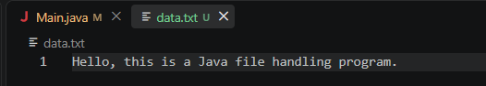
Exercise Qns  and Code | - Create a program to write and read employee details from a file.  import java.io.*;  public class Ex1 {  public static void main (String[] args) {  try {  FileWriter fw = new FileWriter("Exercise/employee.txt");  fw.write("Employee ID: 101\n");  fw.write("Name: Rahul\n");  fw.write("Salary: 50000\n");  fw.close();  FileReader fr = new FileReader("Exercise/employee.txt");  BufferedReader br = new BufferedReader(fr);  String line;  while ((line = br.readLine()) != null) {  System.out.println(line);  }  br.close();  fr.close();  } catch (IOException e) {  System.out.println("File error: " + e.getMessage());  }  }  }  2. Create a Java program to write patient details (patient ID, name, age, and diagnosis) to a file  and read the details from the file for display.  import java.io.*;  public class Exp2 {  public static void main (String[] args) {  try {  FileWriter fw = new FileWriter("Exercise/patient.txt");  fw.write("Patient ID: 101\n");  fw.write("Name: Amit\n");  fw.write("Age: 25\n");  fw.write("Diagnosis: Fever\n");  fw.close();  FileReader fr = new FileReader("Exercise/patient.txt");  BufferedReader br = new BufferedReader(fr);  String line;  while ((line = br.readLine()) != null) {  System.out.println(line);  }  br.close();  fr.close();  } catch (IOException e) {  System.out.println("File error: " + e.getMessage());  }  }  }
Output Screenshots | Ex1:  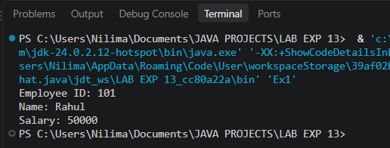  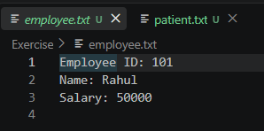  Ex2:  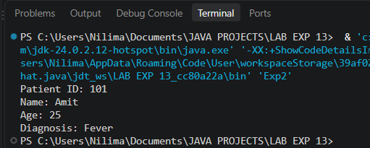  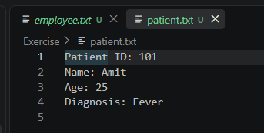
Conclusion | This experiment explores persistent data storage using Java’s standard file stream classes. By implementing BufferedWriter and BufferedReader, it demonstrates how buffered character streams optimize file operations to efficiently write, store, and process structured records across application restarts.

